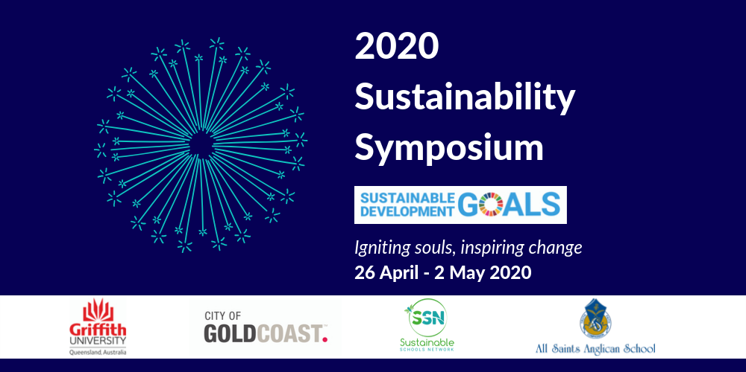

TWEED SHIRE SCHOOLS: EXPRESSIONS OF INTEREST

The Sustainable Schools Network Limited are proud to present our second symposium, the 2020 Sustainability Symposium. A seven-day event across four venues and two states, the 2020 Sustainability Symposium will ignite souls and inspire change. We will present a whole school approach to addressing sustainability in educational contexts by providing learning experiences for students, teachers, operational leaders such as principals, business managers and/or heads of maintenance/cleaning, and parents. Addressing the global Sustainable Development Goals (SDGs) provides the 'glocal' context for the event, as we focus especially on SDG 11, 16 and 17. Building on the success our inaugural event in 2019, the 2020 Sustainability Symposium will deliver training and networking experiences that will ensure schools can meaningfully deliver the cross-curriculum priority sustainability whilst also designing a visionary future.

The 2020 Sustainability Symposium will feature some of the world's leading sustainability educators and Australian heros making a difference in their community. Legends like Jaimie Cloud, Damon Gameau, Prudence Melom, Luka Lesson, Jessica Pinder, Erfan Daliri, Christine McDougall, Larissa Rose, Samantha Morris, Ali Sammel and Cam Mackenzie will take to the stages to inspire, inform and help schools and their communities positively impact their local community. The SSN are especially excited about the 4-day sustainability curriculum masterclass that Jaimie Cloud, from The Cloud Institute in New York, will facilitate. Jaimie is a pioneer in the field of education for sustainability and is internationally recognised for her contribution to the field. This 4-day learning experience is not to be missed if you are committed to embedding sustainability in your lesson plans.

THE OPPORTUNITY FOR TWEED SHIRE SCHOOLS
Similar to 2019, Tweed Shire Council is offering to fund bus transport and ticket costs to enable Tweed students, teachers, operational staff and parents/carers in your school community to attend the full range of inspiring and empowering sessions on offer at this year’s 2020 Sustainability Symposium. Places are limited so it is important that you express your interest in a timely fashion to enable tickets and transportation to be arranged within the allocated budget.

Please complete the form on the following page to express your schools’ interest in participating. EOI’s must be submitted by COB 30 March 2020 via email info@ssn.org.au
EXPRESSION OF INTEREST: 2020 SUSTAINABILITY SYMPOSIUM

School name:
Name of person applying:
Role within the school environment:
Principal
Business Manager
Teacher
Student
Parent/carer
Grounds/maintenance staff
Other ____________________________________
Email address:
Contact telephone number:

Event component of interest
Please select the components of the 2020 Sustainability Symposium you are interested in. You are encouraged to select more than one component to ensure a whole school approach to sustainability. Please ensure you identify the priority of your preference for support from Tweed Shire Council.
28 April 2020, All Saints Anglican School
Student sessions (10 tickets with 1 accompanying adult)
Please indicate which year level/s would like to be considered for this opportunity
___________________________________________________________________________
School Operational Leaders Workshop and Dinner
Please indicate the number of tickets and who would be attending
___________________________________________________________________________
Parent Workshops
Please indicate the number of tickets and who would be attending
___________________________________________________________________________
Continuing Professional Development Dinner Only
Please indicate the number of tickets and who would be attending
___________________________________________________________________________
29 April 2020, Griffith University Gold Coast Campus
Introduction to Education for Sustainability Masterclass
Please indicate the number of tickets and who would be attending
___________________________________________________________________________
29 April – 2 May 2020, Griffith University Gold Coast Campus
Introduction to Education for Sustainability Masterclass and Curriculum Studio
Please indicate the number of tickets and who would be attending
___________________________________________________________________________
Request for information about intended impact
Please outline what specific environmental/sustainability initiative in your school would benefit from participation in the 2020 Sustainability Symposium
___________________________________________________________________________
___________________________________________________________________________

You will be notified after 1 April 2020 to confirm attendance, booking and transport arrangements. If successful to receive partial or full support to attend the 2020 Sustainability Symposium you will be asked to offer further information about your intentions to utilise learning from the event to impact your school community.

Please note: the School Sustainability Awards are open to Tweed Shire Schools in 2020 which will be a great opportunity to develop your intentions for purpose (cash prizes are available). If a school sustainability awards application is received no further submission will be required.

Goodluck, we are looking forward to igniting souls and inspiring change in 2020!

